GIVA SQL Solution

Q) Create a sales table with the following fields:

Customer Name

Email

Phone

Date of purchase

SKUs bought (multiple comma separated values)

Total price

Discount

SOLUTION:

CREATE TABLE SALESDATA(

'Customer_name' varchar(255),

'Email' varchar(255),

'Phone' integer(30),

'Date_of_Purchase' date(30),

'SKU' varchar(255),

'Price' long float(255),

'Discount' long float(255)

);

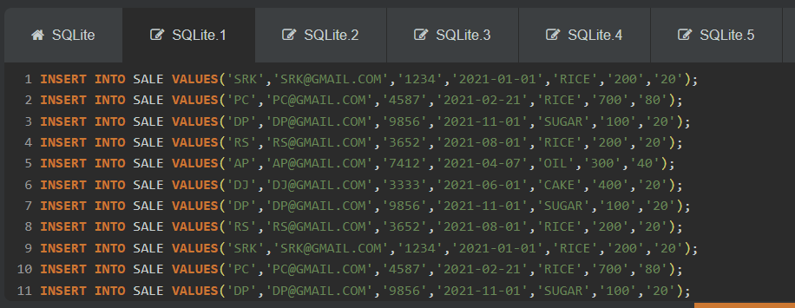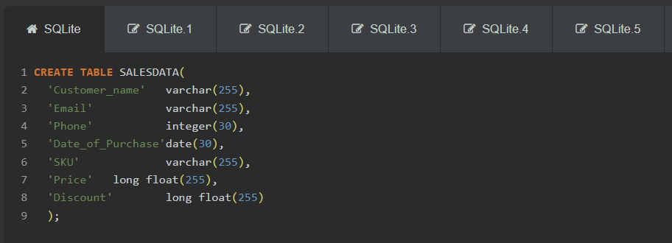

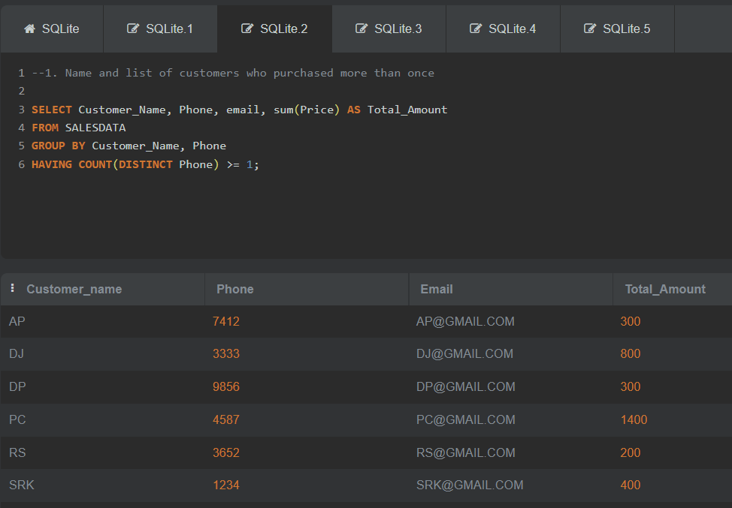

## **1. Name and list of customers who purchased more than once**

Select Customer_Name, Phone, email, sum(Price) as Total_Amount

From SALESDATA

Group by Customer_Name, Phone

Having Count(distinct Phone) >= 1;

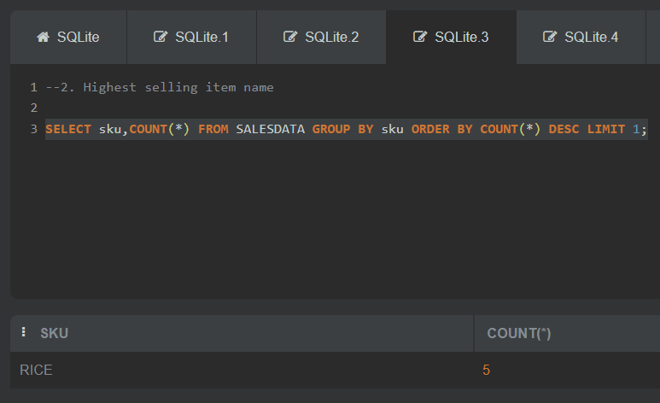

## **2. Highest selling item name**

SELECT sku,COUNT(*) FROM SALESDATA

GROUP BY sku ORDER BY COUNT(*)

DESC LIMIT 1;

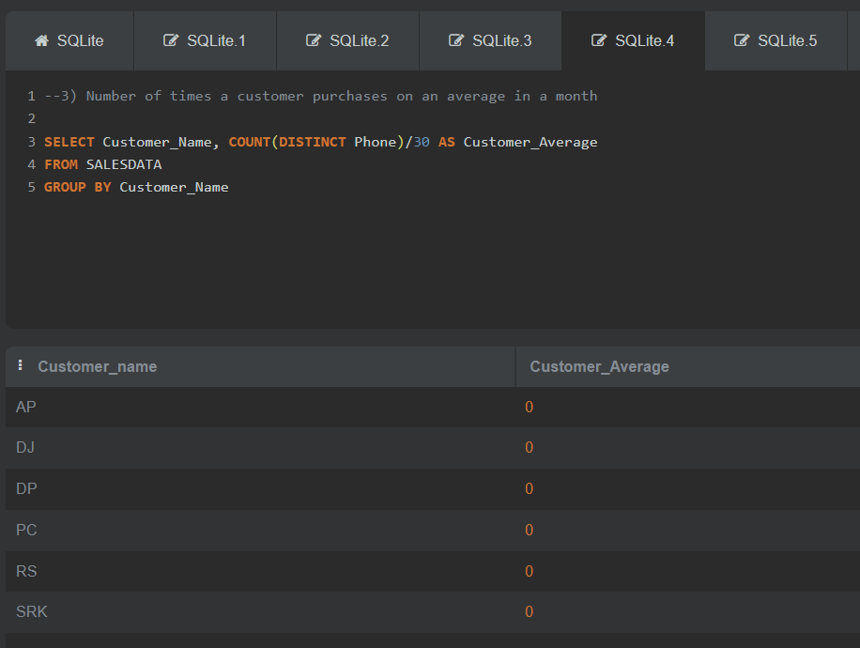

## **3) Number of times a customer purchases on an average in a month**

Select Customer_Name, count(distinct Phone)/30 as Customer_Average

from SALESDATA

group by Customer_Name;

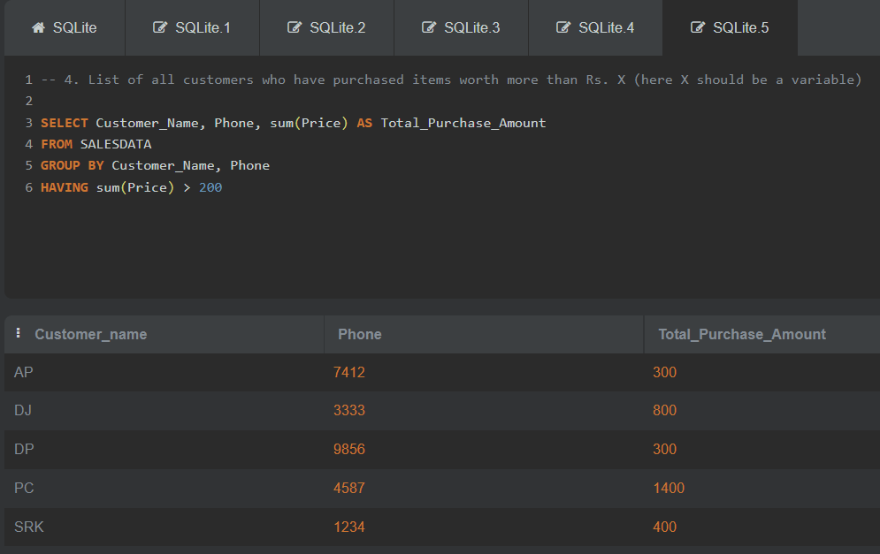

## **4. List of all customers who have purchased items worth more than Rs. X (here X should be a variable)**

Select Customer_Name, Phone, sum(Price) as Total_Purchase_Amount

From SALESDATA

Group by Customer_Name, Phone

Having sum(Price) > 200;